Epub Player
Date | Tuesday, July 28, 2026
Author
Total Pages
Submitted by

Table of Contents

Fixed Layout EPub Standard……………………………………………………………….3
Sample HTML…………………………………………………………………………….4

Fixed Layout EPub Standard

Guidelines need to follow for designing Fixed layouts EPubs :-

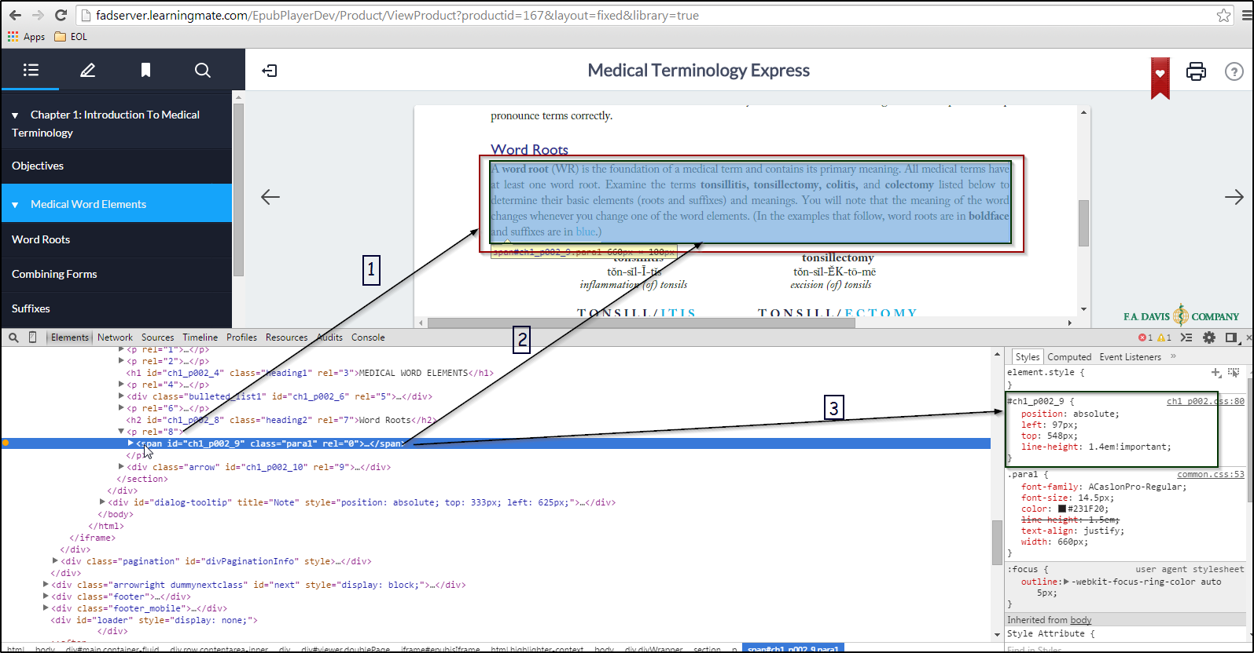

As seeing in the above image following steps need to follow:

- All content should be entered in to <section> tag and under the<section> tag there is <p> tag.
- Under the <p> tag there is one <span> with having unique id with it and all the text content will be added in to that tag i.e <span id=1>contents</span> .
- All the style should be apply only on <span> tag and also need to check after applying style that whether it is not taking any extra space or indent.

Sample HTML

Here are the sample html which will more helpful to create contents

<section xmlns="http://www.w3.org/1999/xhtml" xmlns:epub="http://www.idpf.org/2007/ops" epub:type="chapter" rel="0">

<p rel="0"><span id="ch1_p020_1" class="left_page_num" rel="0">20</span></p>
<p rel="1"><span id="ch1_p020_2" class="chapter_num_left" rel="0">CHAPTER 1<span class="chapter_num_left_pipe" rel="0"> | </span> <span class="chapter_left_title" rel="1">Introduction to Medical Terminology</span></span></p>
<p id="ch1_p020_3" class="heading3" rel="2">Review Activity 1-9</p>
<p id="ch1_p020_4" class="heading2" rel="3">Common Prefixes</p>
<p rel="4"><span id="ch1_p020_5" class="para1" rel="0">Common prefixes, their meanings, and an example of a related term are listed in the following table. First, study the prefix and its meaning and practice pronouncing the term aloud. Then use the information in the following table to complete the meaning of the terms. You may also refer to <span class="txtitalic" rel="0">Appendix A: Glossary of Medical Word Elements</span> to complete this exercise. To understand the meaning of medical terms, it is important to engage actively in activities of this type. Complete all of the exercises, and you will master medical terminology. The first one is completed for you.</span></p>
<p rel="5"><span id="ch1_p020_6" class="table_header" rel="0">Prefix</span></p>
<p rel="6"><span id="ch1_p020_7" class="table_header" rel="0">Term</span></p>
<p rel="7"><span id="ch1_p020_8" class="table_header" rel="0">Meaning</span></p>
<p rel="8"><span id="ch1_p020_9" class="table_body-bold" rel="0"><span class="txt3bold" rel="0">a-*, an-†</span></span><span id="ch1_p020_12" class="table_body" rel="1">without, not</span></p>
<p rel="9"><span id="ch1_p020_10" class="table_body-gstd" rel="0"><span class="txt3bold" rel="0">a</span>/mast/ia</span><span id="ch1_p020_13" class="table_body" rel="1">ă-MĂS-tē-ă</span><span id="ch1_p020_14" class="table_body" rel="2"><span class="txtitalic" rel="0">mast:</span> breast</span><span id="ch1_p020_15" class="table_body" rel="3">–<span class="txtitalic" rel="0">ia:</span> condition</span></p>
<p rel="10"><span id="ch1_p020_11" class="table_body txt1italic" rel="0">Without a breast</span></p>

</section>

