Chapter 2
Participate in safe work practices

Activity 1 – Word Find

The Word Find has (20) hidden words relating to safe work practices. Can you find the words listed below?

Safety
Legislation
Procedures
Emergency
Health
Workplace
PPE
Security
Consultation
Report
Processes
Hazards
Incidents
Identify
Policies
Occupational
Chemical
Maintenance
Environmental
Ergonomics

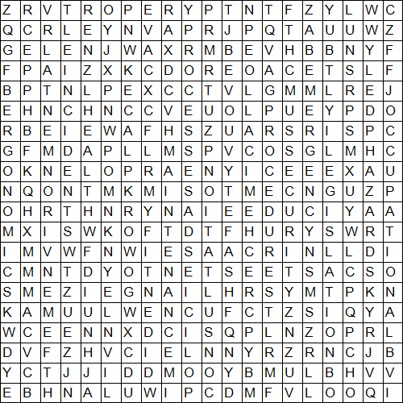
Activity 2 – Word match

Draw a line from the term to the correct definition.

EHO

Hazard

Report

Manual handling

Risk

Duty holder

PPE

Refers to any person who owes a WHS duty under the WHS Act

Something with the potential to cause harm

Personal protective equipment

Usually a written document; e.g., a record of an incident or situation/recommendations for improvements

Lifting procedures – very important to protect the back

Environmental health officer

The likelihood of the hazard actually causing harm

Activity 3 – Fill the gaps

Complete the following text relating to security by adding in the correct word/s from the table into the missing spaces below.

damaging | security | theft | violent | unlawful
packages | theft | assault | property | terrorism

Vandalism is the malicious of by customers, staff or outside influences.

An on a staff member or a customer, whether within an establishment or outside it, is a very serious matter. All assaults, physical and verbal, should be dealt with and treated with the utmost importance.

can cover a range of offences, including the dishonest and taking of food and drink (by staff as well as by customers), or of equipment, furniture or furnishings; taking as souvenirs or keepsakes items that are of value; and armed hold-ups.

Aggravated or robbery, where the use of or aggressive behaviour can lead to assault in addition to theft, has to be assessed as a security risk.

has become a threat that customers and staff are very aware of, and it should be taken very seriously. All threats of this nature, such as telephone calls and suspect , should be dealt with very carefully.
Activity 4 – Short answer questions

Give brief answers to the questions below relating to work health and safety in the hospitality industry.

- What can be the result of poor ergonomics at a kitchen workstation?

- Give five examples of personal protective equipment commonly used in the kitchen.

a.
b.
c.
d.
e.

- What is work health and safety?

- List four forms injuries commonly associated with manual handling in the kitchen.

a.
b.
c.
d.

- What are the three elements required to start a fire?

a.
b.
c.

Activity 5 – Research activity

In the table below, conduct an inspection of a commercial kitchen and identify three potential hazards, and suggest a preventative action that could eliminate the risk.

Hazard | Preventative actions

