**Issues observed on EDM-DTEST -**

<http://devmigrationdavisedge.fadavis.com/productlist>

1. Browse Sites drop-down does not display.

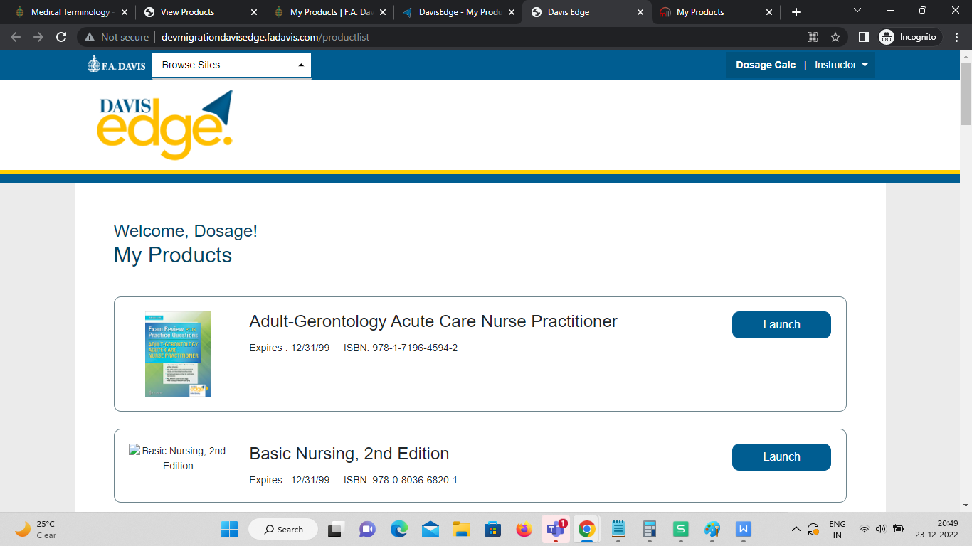

2. FADavis Application - Duplicate Products are displayed in My Favourites section, My Products section & Other Products being used in my Program -

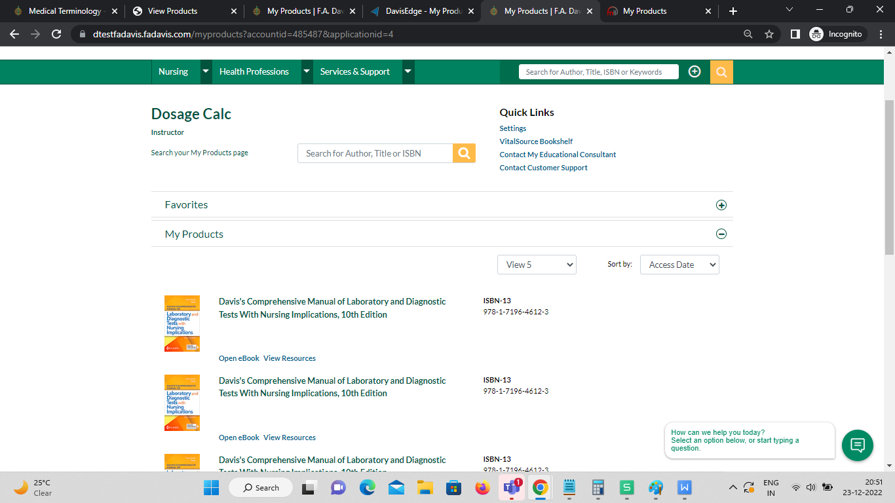

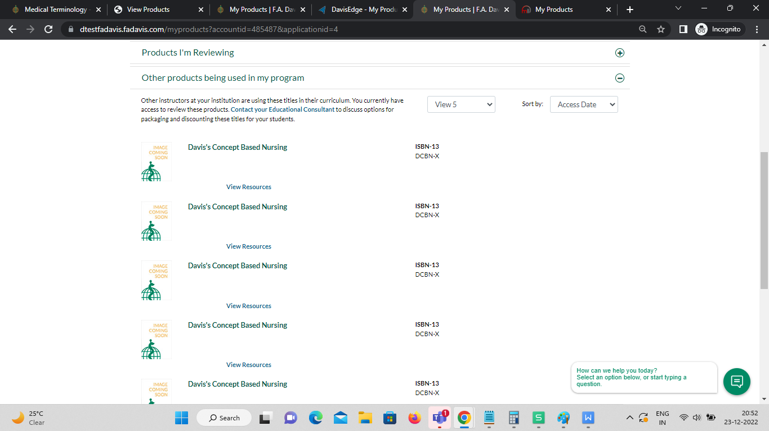

3. Product Images does not display on Shopping Cart page -

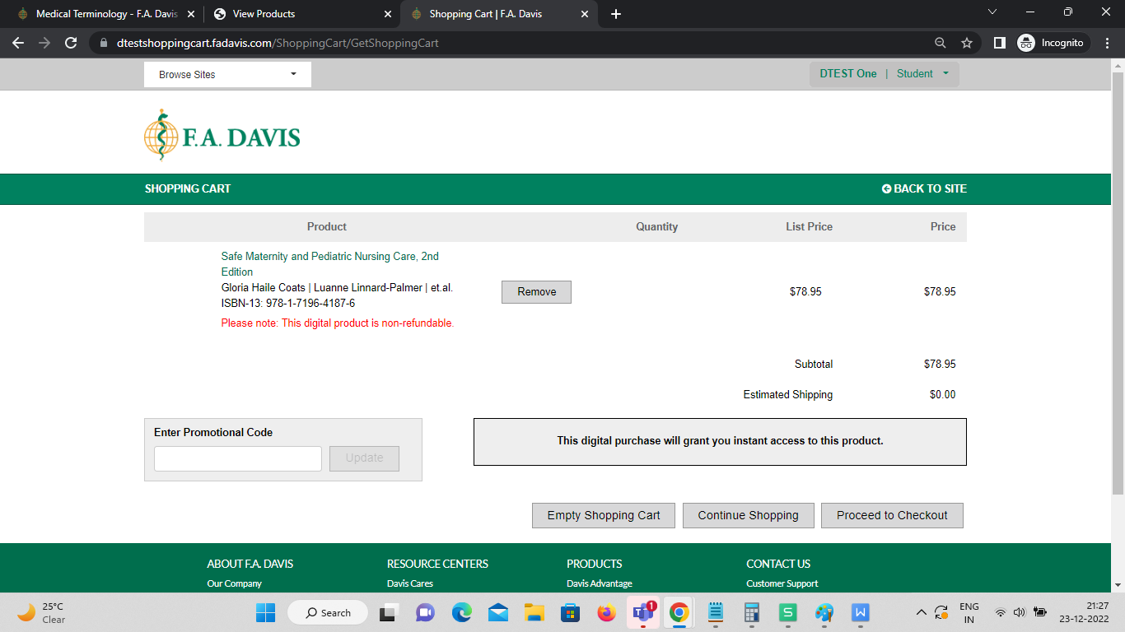

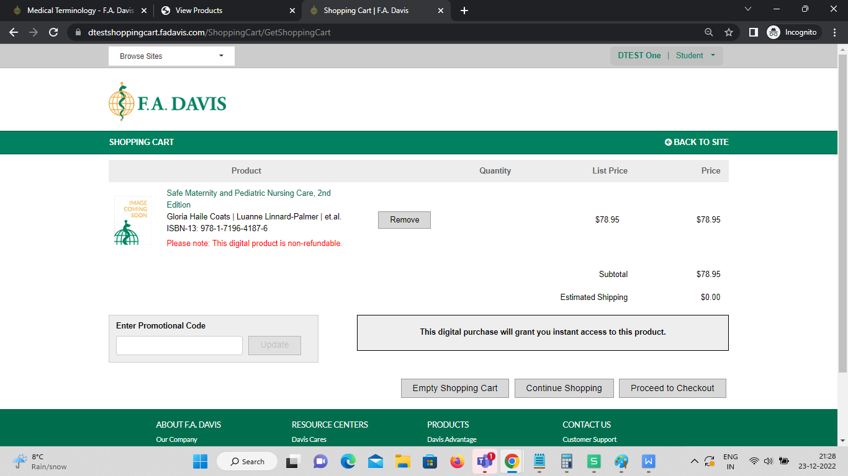

4. Clicking on ACCESS NOW button redirects the User to Davis EDGE - ACE

