### Design Specification

**Wireframe 1a:** Manage Instructors Link (Calculating Dosages Online)

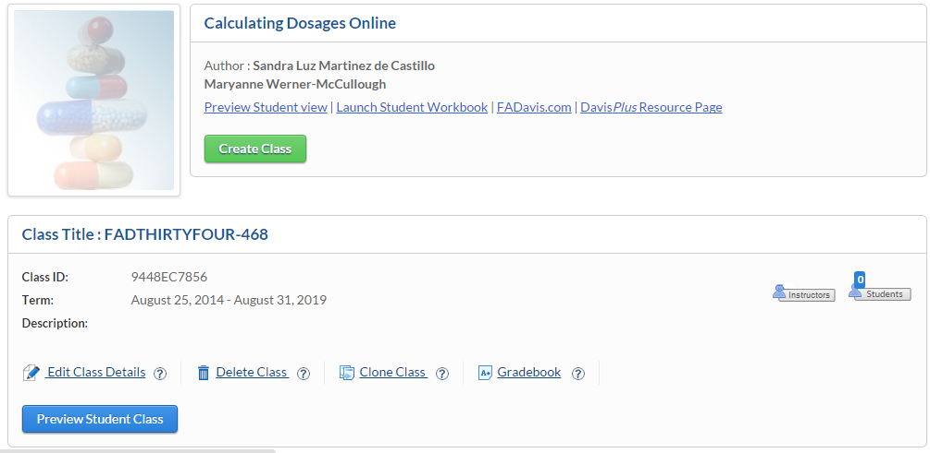

**Wireframe 1b:** Manage Instructors Link (Medical Language Lab)

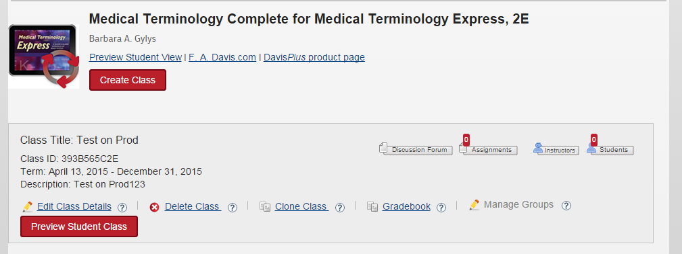

**Wireframe 1c:** Manage Instructors Link (Davis Edge)



**Wireframe 1d:** Manage Instructors Link (Kinesiology in Action)

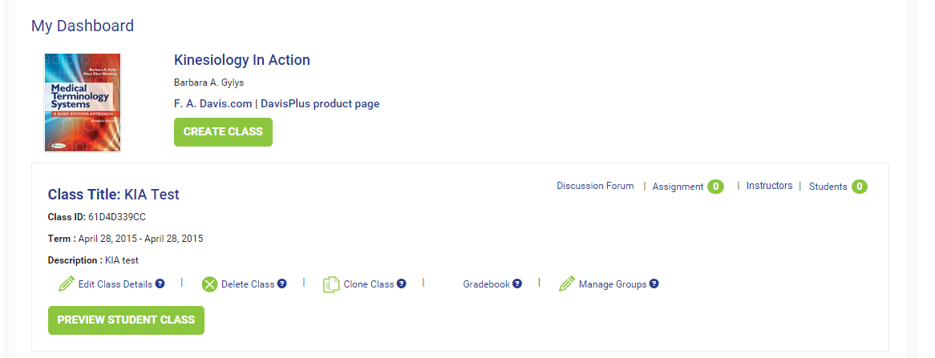

**Wireframe 2:** Manage Instructors Page

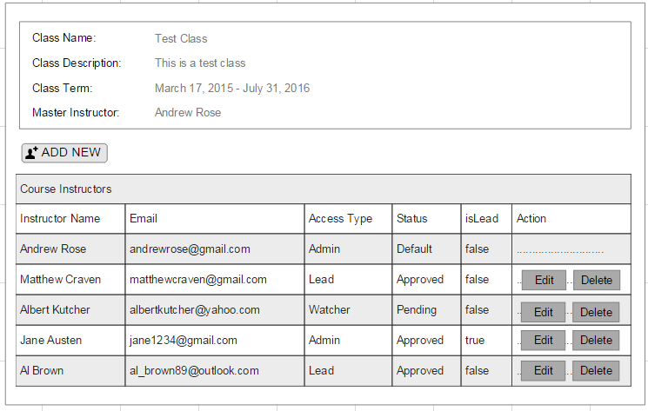

**Wireframe 3:** Add Instructor Pop-up (default)

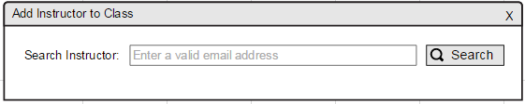

**Wireframe 4:** Add Instructor Pop-up displaying search results for e-mail search

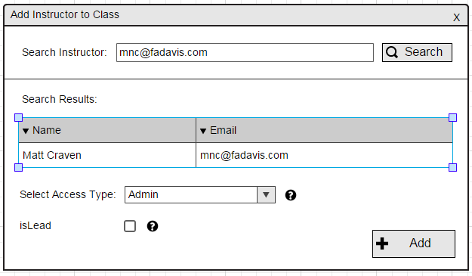

**Wireframe 4a:** Add Instructor Pop-up displaying form to add instructor when instructor does not have product access

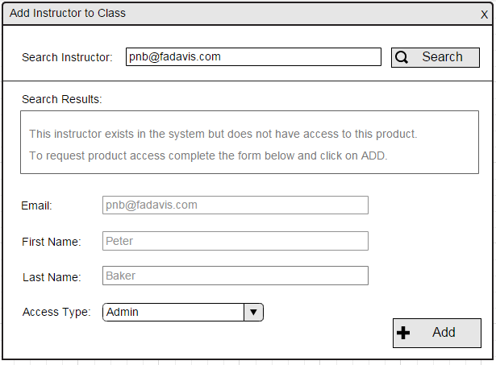

**Wireframe 4b:** Add Instructor Pop-up displaying form to add instructor when instructor does not exist in system

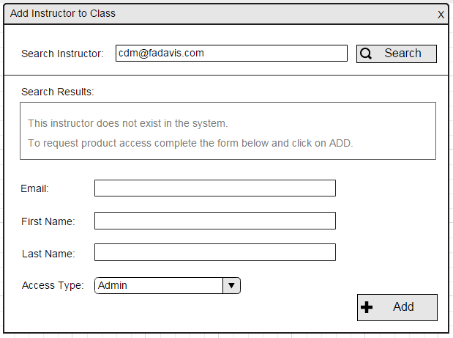

**Wireframe 5:** Edit Instructor pop-up

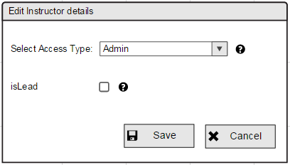

**Wireframe 6:** Instructor feedback pop-up displaying Instructor name and feedback

